

The University of Azad Jammu and Kashmir, Muzaffarabad

Name | Jawahir Ali
Course Name | Computer Architecture and Logic Design
Submitted to | Engr. Sidra Rafique
Semester | 2nd
Session | 2024-2028
Roll No | 2024-SE-34
Lab No | 03

Department of Software Engineering

Procedure to Connect 7408 (AND Gate IC) in EWB

1. Open EWB Software
- Start the Electronic Workbench on your computer.

2. Place the 7408 IC
- Click on Place → Component.
- Go to the TTL or Digital library.
- Search and select 7408 (it’s the Quad 2-input AND gate).
- Place the 7408 IC onto the workspace.

3. Connect the Power Supply
- Pin 14: Connect it to +5V (power supply).
- Pin 7: Connect it to Ground (GND).
This powers up the IC so it works properly.

4. Set up Inputs
- From Inputs menu, pick Logic Switches.
- Place two switches (one for each input).
- Connect:
  - One switch to Pin 1 (Input A1).
  - One switch to Pin 2 (Input B1).

5. Set up Output
- From Indicators menu, place an LED.
- Put a 330Ω resistor in series with the LED (protects the LED).
- Connect:
  - Pin 3 (Output Y1) → Resistor → LED → Ground.

6. Start Simulation
- Click Run (or Start Simulation button).

7. Test the Circuit
- Use the switches to turn inputs ON or OFF.
- Observe the LED:
  - LED ON = Output is HIGH (1).
  - LED OFF = Output is LOW (0).
- Try all combinations (00, 01, 10, 11) and record the results.

AND GATE
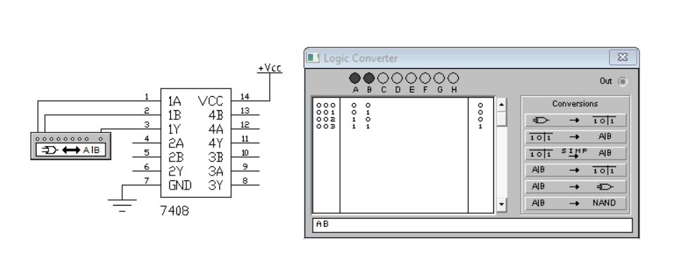
Truth Table
Output
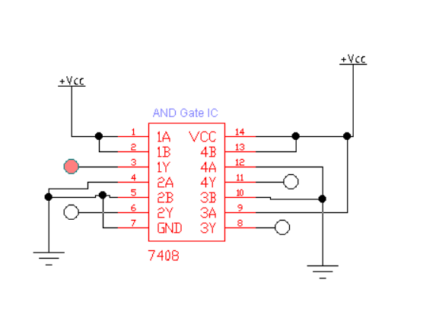

Procedure to Connect 7432 (OR Gate IC) in EWB

1. Open EWB Software
- Start Electronic Workbench on your computer.

2. Place the 7432 IC
- Click Place → Component.
- Find the TTL or Digital family.
- Search for 7432 (Quad 2-input OR gates).
- Place the 7432 IC on your workspace.

3. Connect Power to the IC
- Pin 14: Connect to +5V (positive supply).
- Pin 7: Connect to Ground (GND).
⚡ This step powers the IC so it can work correctly during simulation.

4. Set Up Inputs
- From the Inputs menu, place two logic switches.
- Connect:
  - First switch to Pin 1 (Input A1).
  - Second switch to Pin 2 (Input B1).

5. Set Up Output
- From the Indicators menu, place an LED.
- Add a 330Ω resistor between the output and the LED.
- Connect:
  - Pin 3 (Output Y1) → Resistor → LED → Ground.

6. Start the Simulation
- Click Run to start the simulation.

7. Test and Observe
- Toggle the switches through different combinations (00, 01, 10, 11).
- Watch the LED:
  - LED ON = Output is HIGH (1).
  - LED OFF = Output is LOW (0).
- Record the output to make your truth table.
OR GATE
Truth table
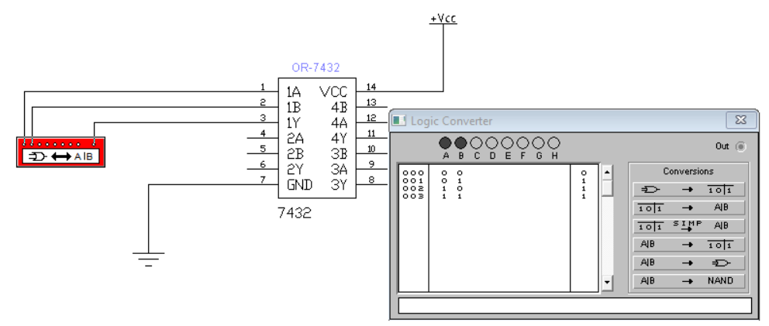
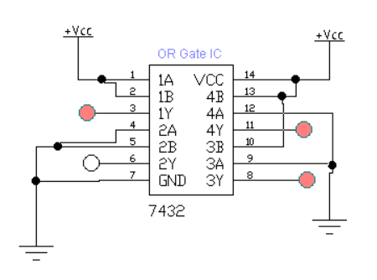
Output

Procedure to Connect 7400 (NAND Gate IC) in EWB

1. Open EWB Software
- Start Electronic Workbench on your computer.

2. Place the 7400 IC
- Go to Place → Component.
- Find the TTL or Digital library.
- Search for 7400 (Quad 2-input NAND gate).
- Drag and place the IC on your workspace.

3. Connect Power to the IC
- Pin 14: Connect it to +5V (positive supply).
- Pin 7: Connect it to Ground (GND).
⚡ This powers up the IC so it works properly in the simulation.

4. Setup Input Connections
- From the Inputs menu, place two logic switches.
- Connect:
  - First switch to Pin 1 (Input A1).
  - Second switch to Pin 2 (Input B1).

5. Setup Output Connection
- From the Indicators menu, place an LED.
- Add a 330Ω resistor in series with the LED.
- Connect:
  - Pin 3 (Output Y1) → Resistor → LED → Ground.

6. Start the Simulation
- Press the Run button to start the simulation.

7. Test and Observe
- Turn ON and OFF the switches in different combinations (00, 01, 10, 11).
- Watch the LED:
  - LED ON = Output is HIGH (1).
  - LED OFF = Output is LOW (0).
- Record the results for each combination to create the truth table.
NAND GATE
Truth table
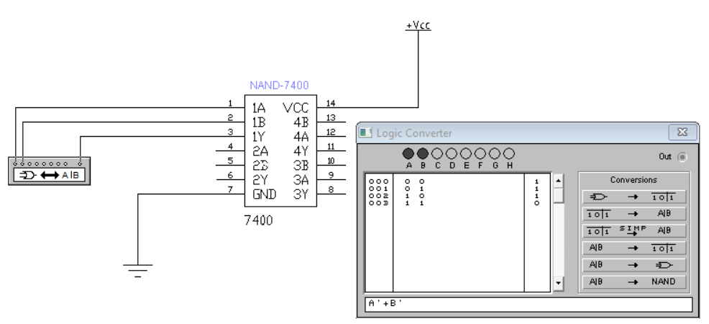
Output
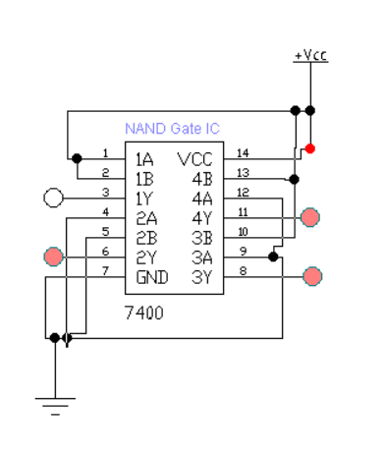

Practical Work in Lab
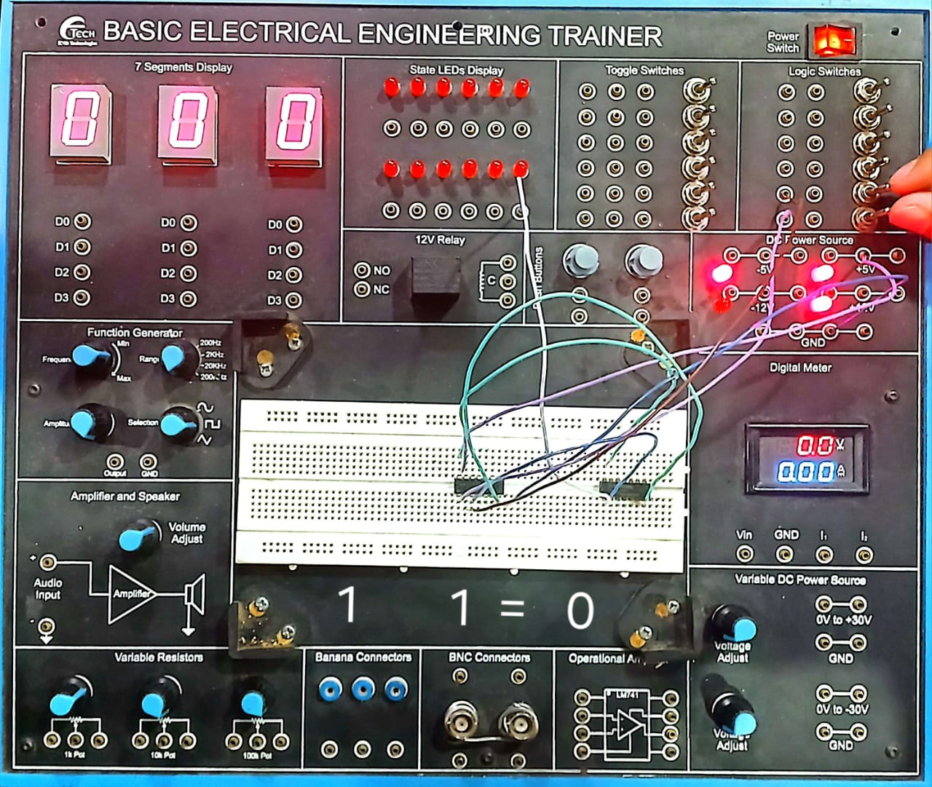

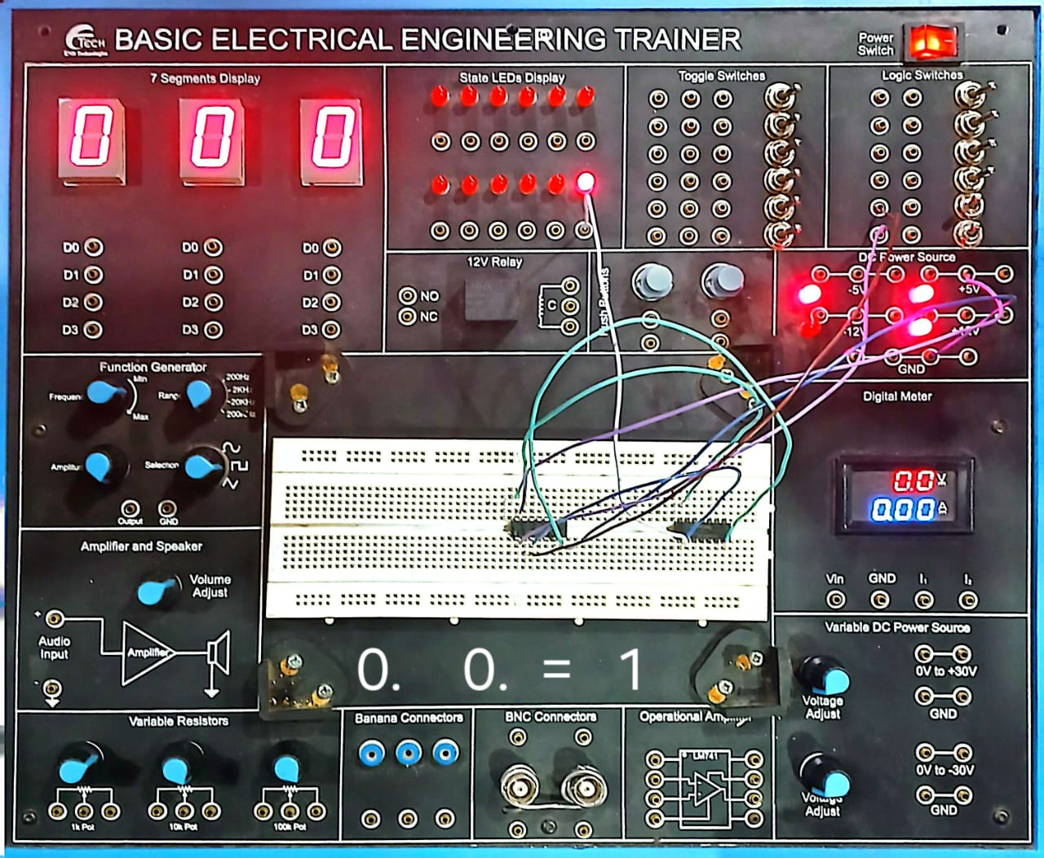

Procedure to Connect 7402 (NOR Gate IC) in EWB

1. Open EWB Software
- Start the Electronic Workbench on your computer.

2. Place the 7402 IC
- Click Place → Component.
- Go to TTL or Digital library.
- Search for 7402 (Quad 2-input NOR gates).
- Place the 7402 IC onto your workspace.

3. Connect Power to the IC
- Pin 14: Connect to +5V (positive power supply).
- Pin 7: Connect to Ground (GND).
⚡ Powering the IC is necessary to make it work properly.

4. Set Up Inputs
- From the Inputs section, place two logic switches.
- Connect:
  - First switch to Pin 1 (Input A1).
  - Second switch to Pin 2 (Input B1).

5. Set Up Output
- From the Indicators section, place an LED.
- Add a 330Ω resistor between the output and LED.
- Connect:
  - Pin 3 (Output Y1) → Resistor → LED → Ground.

6. Start the Simulation
- Click Run to start the simulation.

7. Test and Observe
- Change the switches to different combinations (00, 01, 10, 11).
- Watch the LED:
  - LED ON = Output is HIGH (1).
  - LED OFF = Output is LOW (0).
- Write down the results to create the truth table.

NOR GATE
Truth table
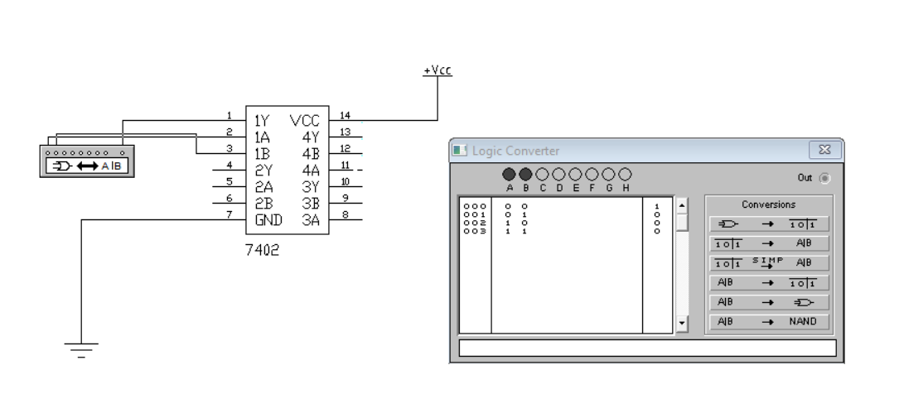
Output
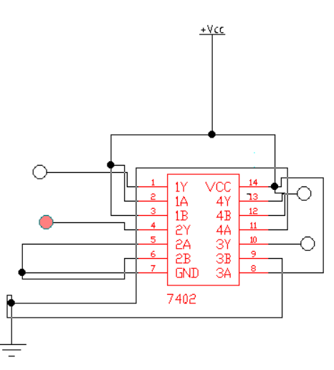

1. Open EWB Software
- Start Electronic Workbench on your computer

2. Place the 7404 IC
- Click on Place → Component.
- Find the TTL or Digital library.
- Search for 7404 (Hex Inverter/NOT gates).
- Place the 7404 IC onto your workspace.

3. Connect Power to the IC
- Pin 14: Connect to +5V (positive power).
- Pin 7: Connect to Ground (GND).
⚡ This step powers the IC so it works properly.

4. Set Up Input
- From the Inputs menu, place one logic switch.
- Connect the switch to Pin 1 (Input A1).

5. Set Up Output
- From the Indicators menu, place an LED.
- Add a 330Ω resistor between the output and LED.
- Connect:
  - Pin 2 (Output Y1) → Resistor → LED → Ground.

6. Start the Simulation
- Click Run to start simulation.

7. Test and Observe
- Turn the switch ON and OFF (0 or 1).
- Observe the LED:
  - If input is 0 → LED turns ON (Output 1).
  - If input is 1 → LED turns OFF (Output 0).
NOT GATE
Truth table
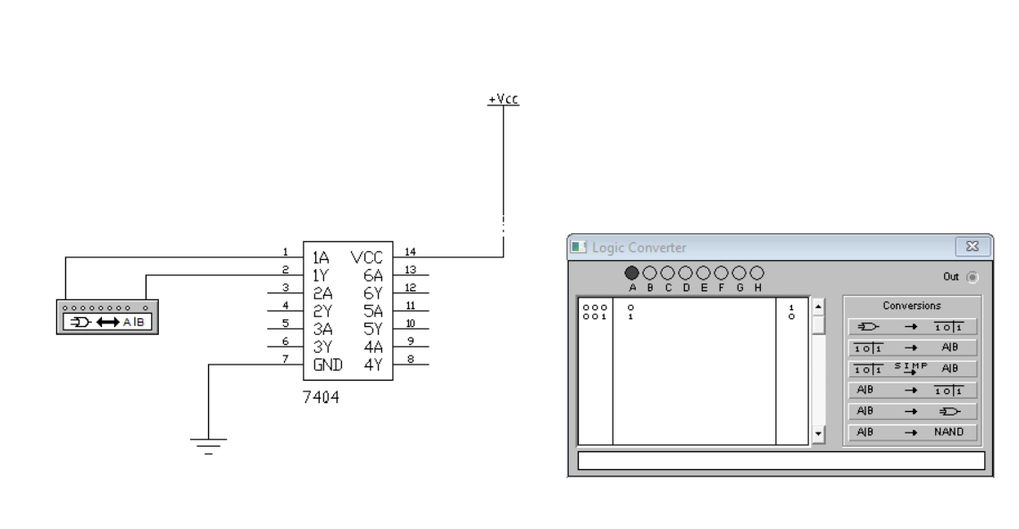

Output
